**East West University**

**FALL-2020**

**Project Report**

**Design a Full-fledged Network for an Organization with Multiple Subnets**

**Course Code:** CSE405

**Course Title:**Computer Networks

**Section:** 01

**Submitted to:**

Dr. Anisur Rahman

Assistant Professor

Department of Computer Science & Engineering

**Submitted by:**

Mahmud Jamil

ID: 2017-2-60-147

**Title:**

Design a Full-fledged Network for an Organization with Multiple Subnets.

**Project Statement:**

This is mini project on INTERNATIONAL Apollo University is an enterprise that owns a large number of computers, with a complex network infrastructure. Apart from wired internet access to all the classrooms, labs, employee PCs, library and other administrative and academic wings, the university also provides wireless internet access for everyone. On top of that the university runs a number of complex networked systems to support several of its business process like admissions, advising, results, eTender, library management, accounts and so on. This complex network infrastructure is subnetted and switching/routing mechanisms are in practice.

The task is to create a complete model of a complex network by discovering the interconnectivity of the systems and subnetworks, which will reflect the INTERNATIONAL Apollo University’s structure and facilities, features within the network.

**Used Components:**

1. PC
2. Switch
3. DHCP Server
4. DNS Server
5. Web Server
6. Smart Phone
7. Router

In my project, there is one server (DHCP), which is connected to a switch that is connected to many other campuses that refers to main campus, AB-1 building, AB-2 building , AB-3 building, AB-4 building, AB-5 building. We have created some servers like web server, DNS server and DHCP server in our main campus, and by using these server we will handle these 5 campuses.

We have also used wireless router which help the university students and faculties to browsing internet through their mobile or laptops. For security reason we used private password to those router. DHCP allows moving a computer, such as a laptop, among various locations without reconfiguring the TCP/IP setting. For example, if a faculty member has a laptop which he wanted to take from his office to a networked classroom to present in class, DHCP will allow the laptop to hook to the network in both locations without reconfiguring the computer. Or if a student has a laptop she wishes to use to access the network in various locations around campus, DHCP will handle the TCP/IP configuration. In the DHCP server there are few numbers of ports where we have used only one port to connect a switch that creates a sub-network. From that switch port we have connected many other switches. These are the wired network connections. I have used 6 wireless network routers so that one can connect there tablet use internet service.Using these four configurations, I have tried to create that complete model of complex network.

**Physical Diagram:**

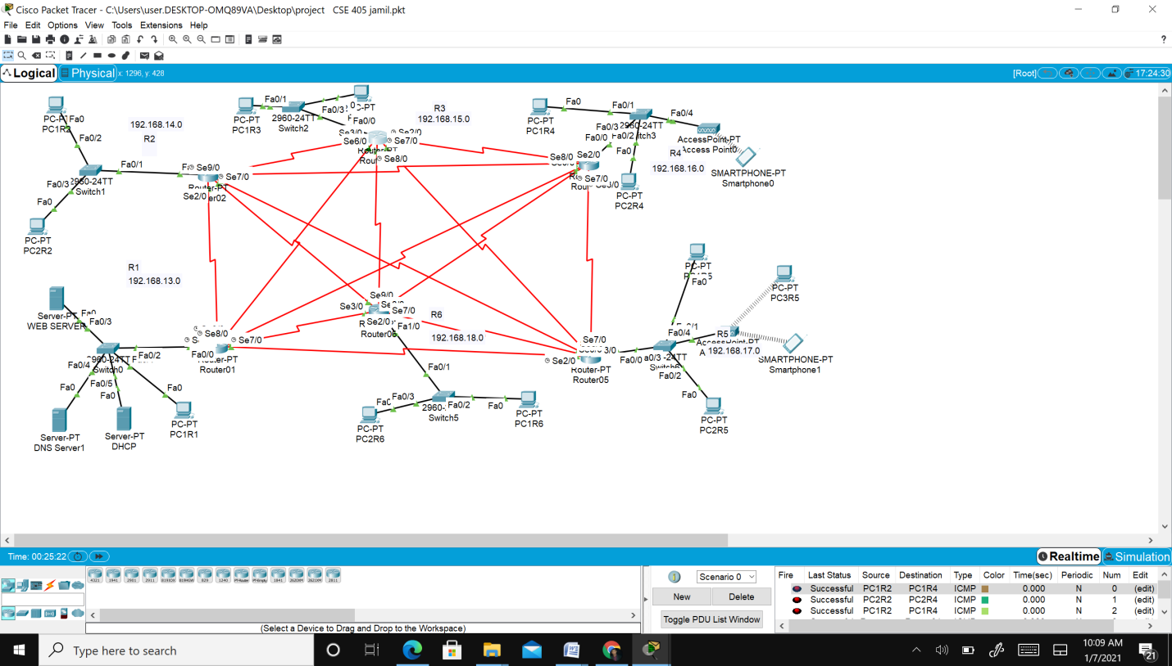

Network Model in Cisco Packet Tracer

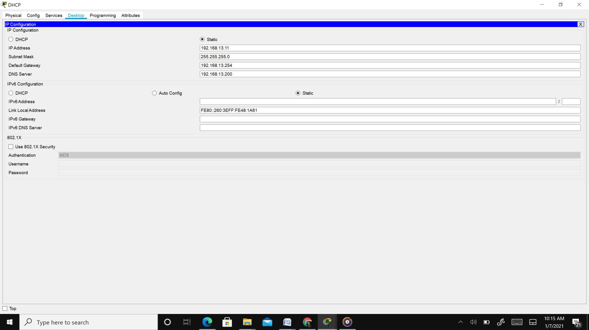

IP configuration of DHCP server

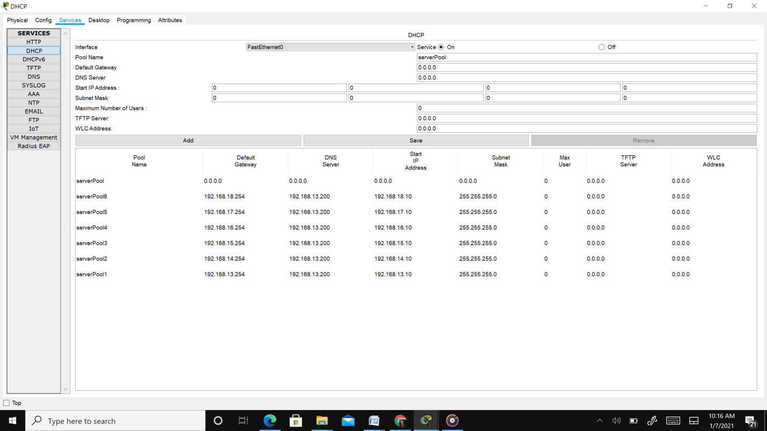

Server Pool

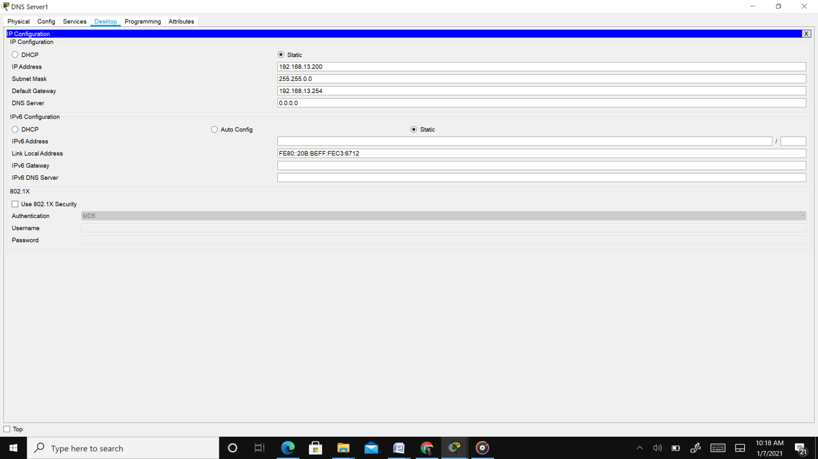

IP configuration of DNS server

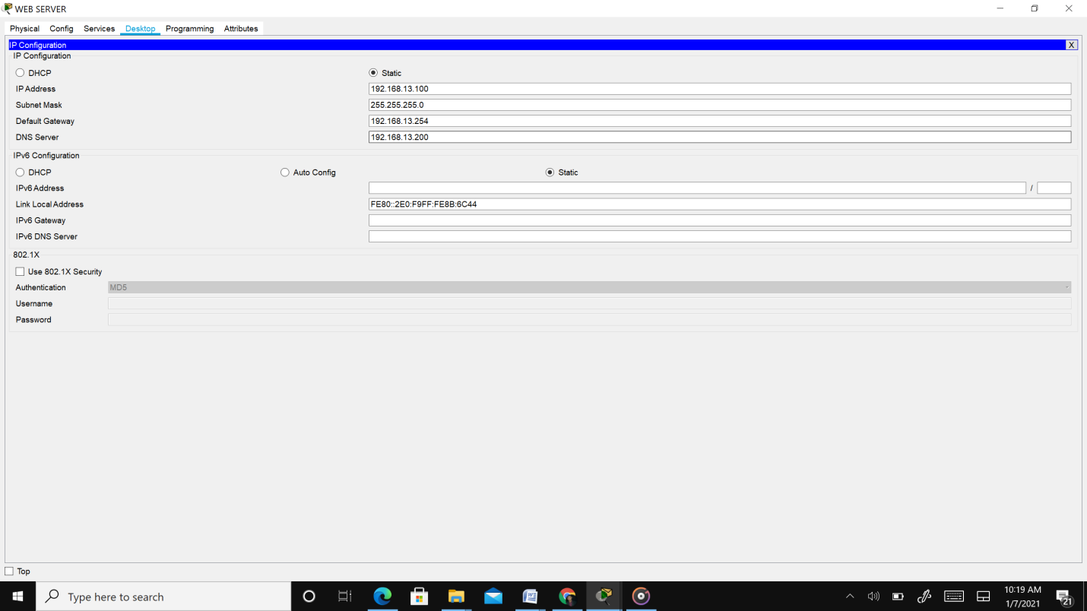

IP configuration of WEB server

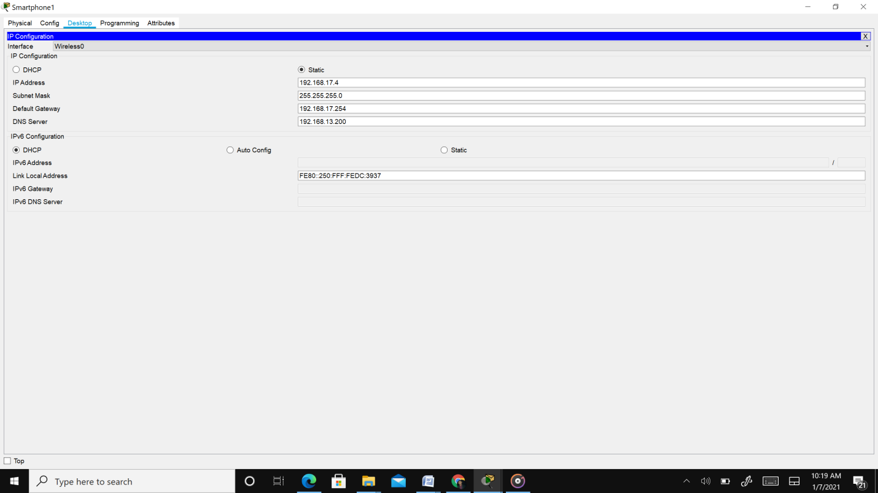

IP configuration of SMART PHONE server

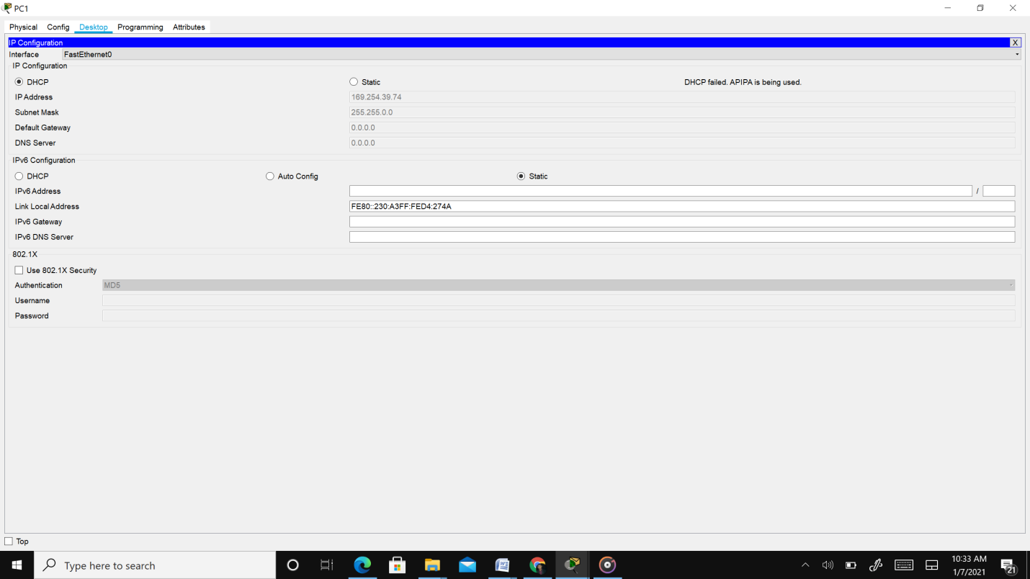

DHCP IP configuration of PC

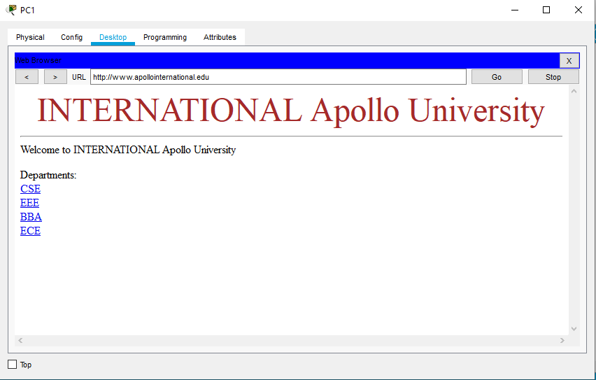

WEB browser page of International Apollo University

**Future plan:**

We will use all types of class (IP) so that we can use more number of ip address. To make more secure I will use sub netting. To extend the area of the university there are some extra ports which can be used to further extension of the university.

**Conclusion:**

Though we have faced some problems but at the end I could be able to implement my plan according to project description, but I could not able to reach to my best. I did not use all classes in my project and I did not use subneting also. I have implemented DNS, DHCP, WEB server in Cisco Packet Tracer, where the configuration of DHCP is automatically assign IPv4 address to any other host from the assigned IPv4 address block of our design.